

**SharePoint: Add Workflow, and Use In-Place Record**

Assignment 4

INFO 3250

Apr 3, 2018

LiWen Tan

**Task 1, Add a Workflow**

Screen shot 1: The Contract Approval Workflow, which is associated with a user-defined content type “Contract Doc Type”, is created by the site administrator

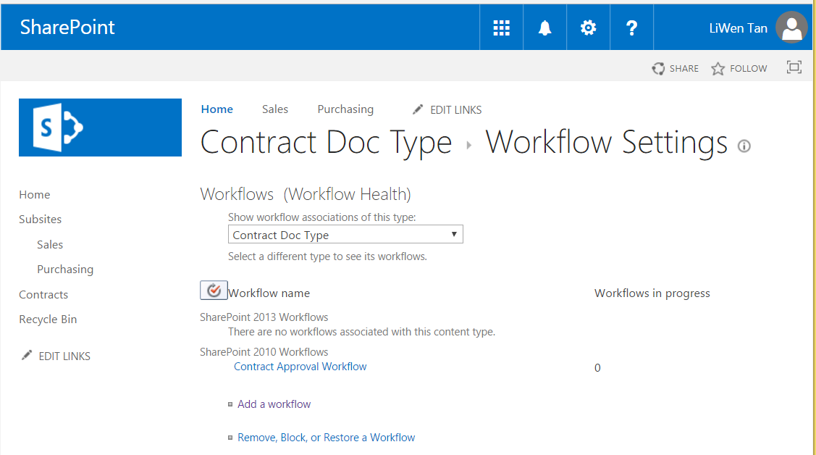

Screen shot 2: The Contract Approval Workflow, which has been attached to a document (e.g., Sales Contract 001), is started by another user (i.e., staffA in this example). In the Contract Approval Workflow column, the document’s status is “In Progress”.

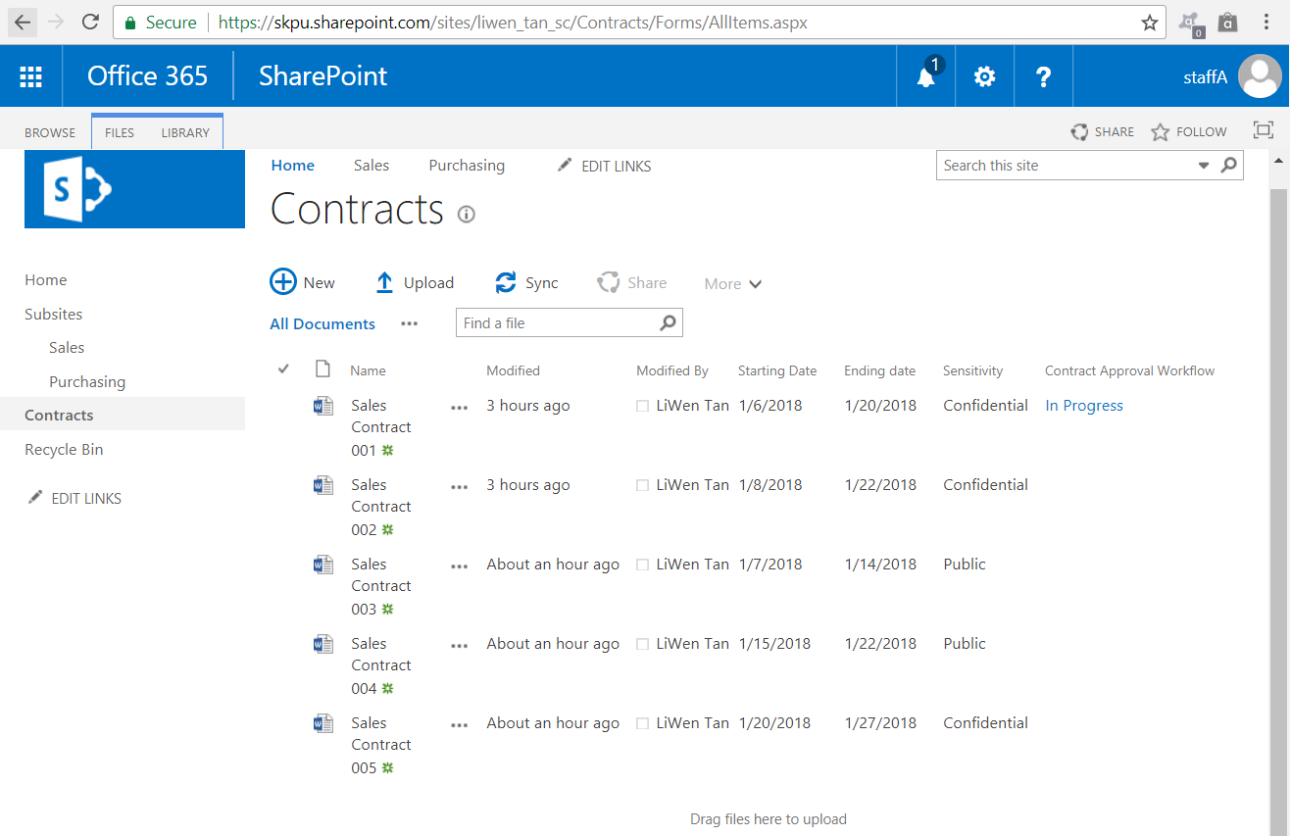

Screenshot 3: The Contract Approval Workflow requires an appointed person to approve the document. Logon as the administrator (i.e., LiWen Tan in this example), complete this form by entering a comment, and then click on the Approve button. 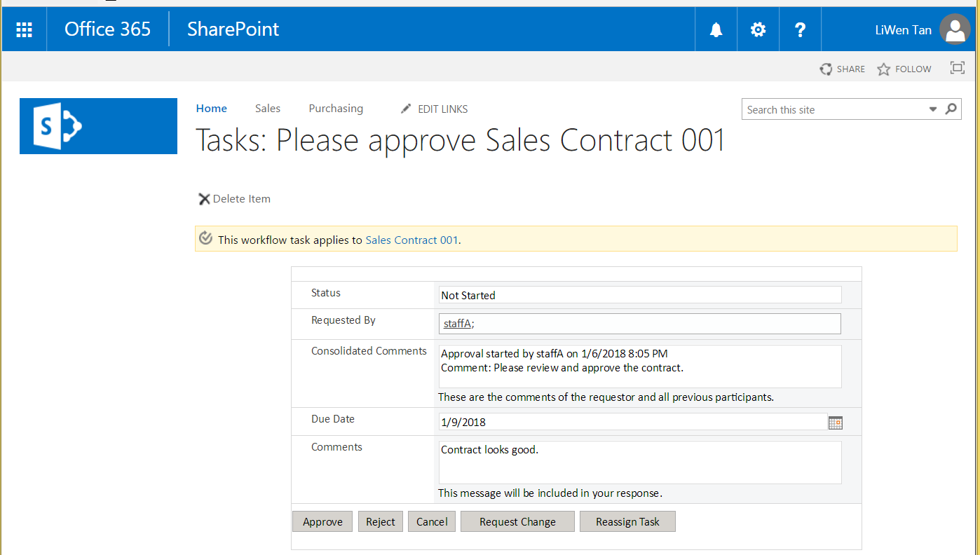

Screenshot 4: After the Approve button has been clicked, the Contract Approval Workflow column shows the status of the document (e.g., Sales Contract 001) is now “Approved”.

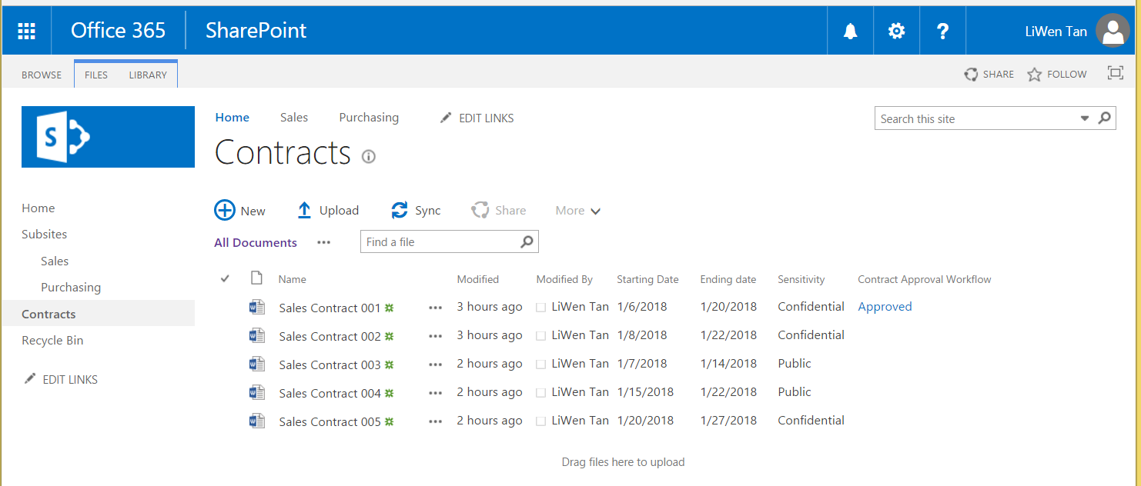

**Task 2, Use in-place record**

Screenshot 1: A retention policy, which is defined by the site administrator (i.e., LiWen Tan in this example), has been attached to the user-defined content type of “Contract Doc Type”.

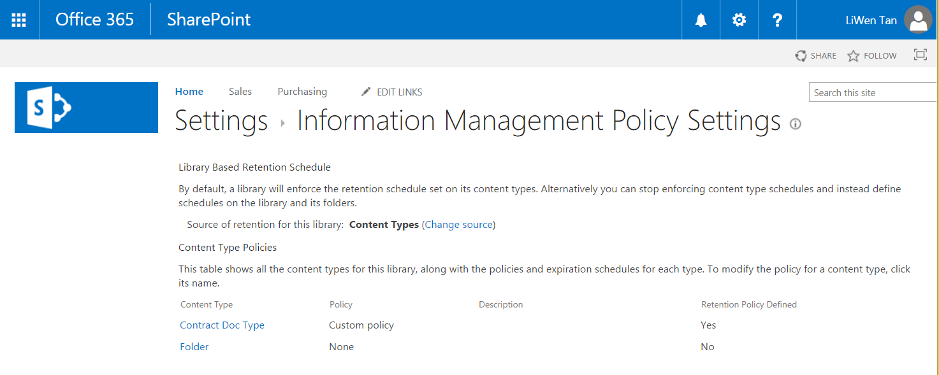

Screenshot 2: After the document (e.g. Sales Contract 001 in this example) has been declared as an In-Place record, its compliance details can be viewed. In this example, a retention stage states that this record (Sales Contract 001) will be moved to the recycle bin one day after it is created.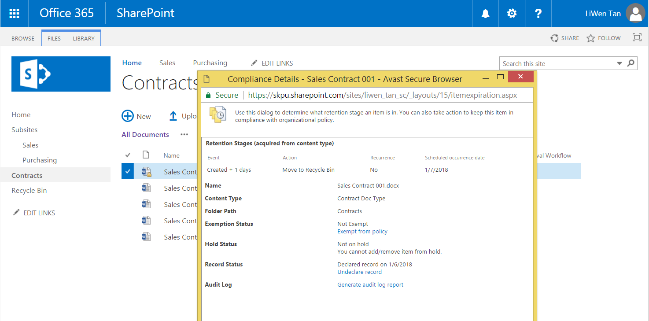

Screenshot 3: After the document (e.g. Sales Contract 001 in this example) has been declared as an in-place record, another users (e.g. staffA) will see a “lock” icon attached to the document icon. Also, the Edit Document feature for the document is blocked.

